**HEALTH CARE**

To **control the spread of diseases and reduce the growing rates of mortality** due to lack of adequate health facilities, special attention needs to be given to the health care in rural areas.

Since access to healthcare services is a key component to quality outcomes, rural providers play a significant role in delivering timely, effective and safe care. Rural emergency rooms are often the frontline when a quick response is vital. Rural Emergency Departments can now even leverage telemedicine technology to connect patients to off-site specialists.

Medical Emergency

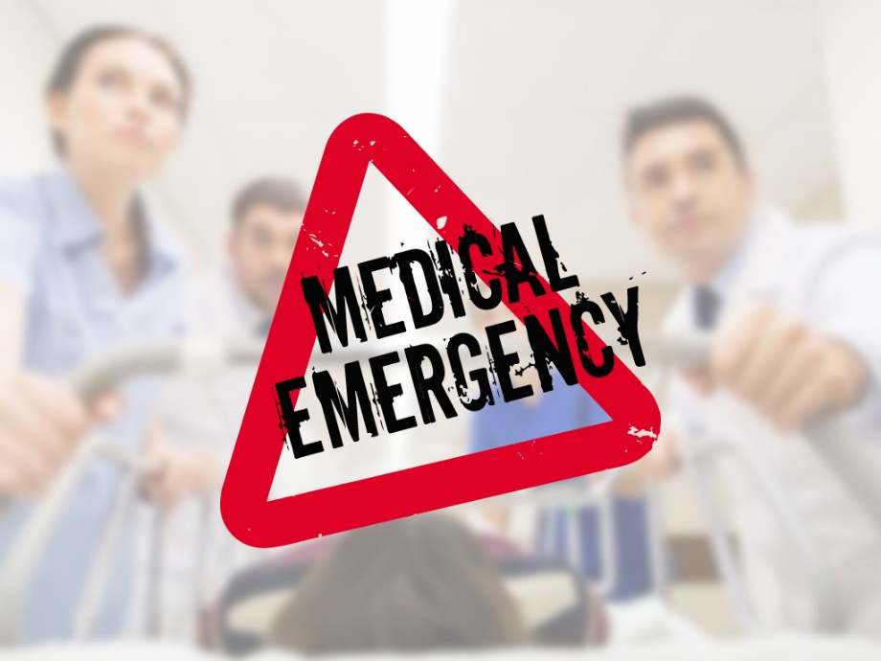

For example, a patient from our community undergoing a stroke would be brought to the nearest hospital—our rural hospital. Telemedicine can be used to instantly connect with a neurologist from a big-city hospital (through video and other cutting-edge software) who can remotely assess, diagnose and guide treatment to save that patient’s life. If our rural hospital—and many just like ours—did not exist, the nearest hospital would be nearly 20 minutes or more away for this patient and thousands more. When minutes count, rural hospitals can and do save lives. Some Villages in India still do not have any basic medical necessities available so we have started this foundation with aim of providing it.

Diagnostics

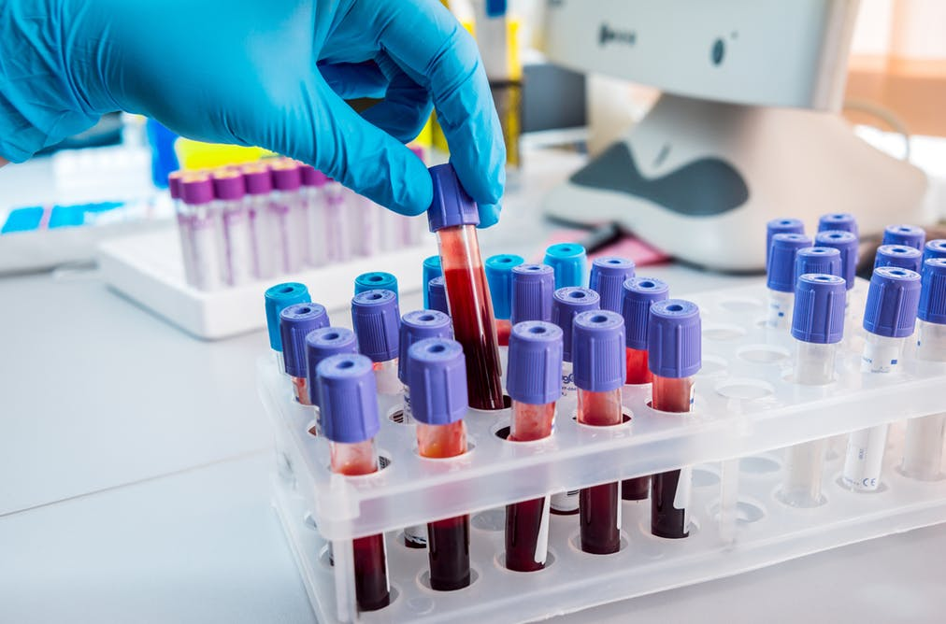

Most of the Basic Necessities are not available in most parts of india. Lab and X-Ray facilities our aim is to fix it.

Medicine Distribution



Most of the Basic Medicines are not available in most parts of india. Some Villages in India still do not have any basic medical necessities available so we have started this foundation with aim of providing it.

Medical Infrastructure

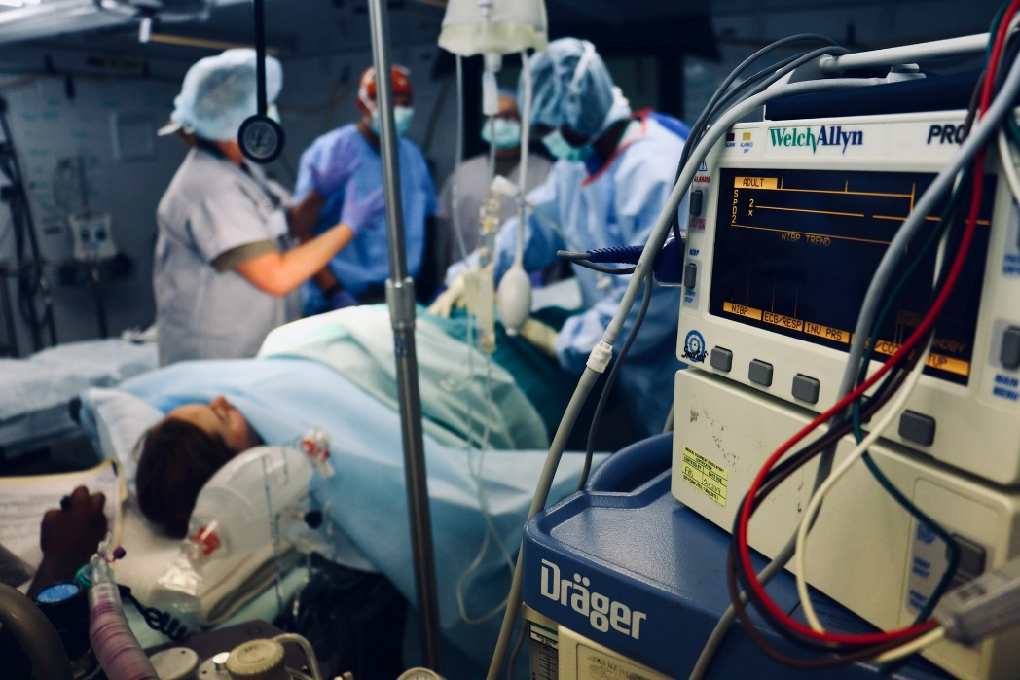

A variety of elements contribute to these problems in rural areas, including a **declining population**, economic stagnation, shortages of physicians and other health care professionals, a disproportionate number of elderly, poor, and underinsured residents, and high rates of chronic illness.

Medical Camp

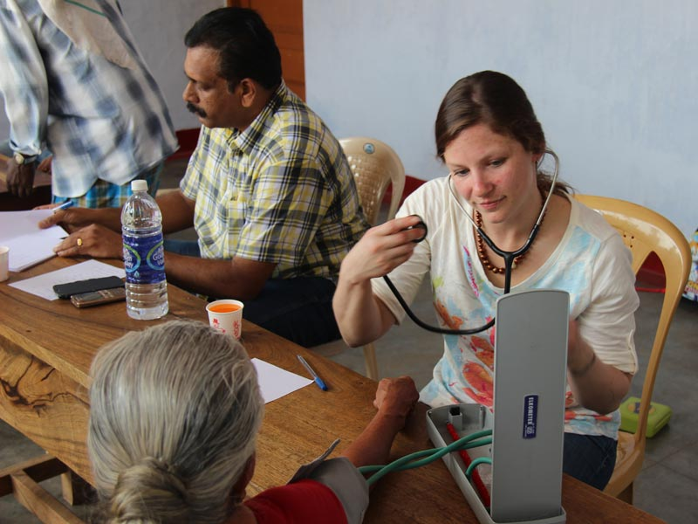

The main objective of a medical camp is **to provide initial care to people in life-threatening conditions** which reflect the unique strengths and goals of medical ethics